Vocabulary Word Map
Definition in your own words Synonyms

Use meaningfully in a sentence Draw a picture of it

Vocabulary Word

Vocabulary Word Map

Community

Community

Use meaningfully in a sentence

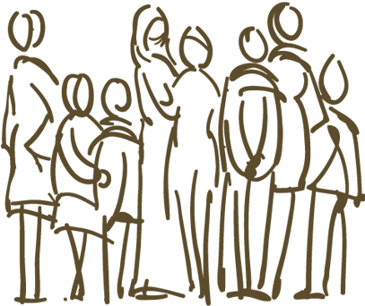

Synonyms
Definition in your own words

