Literacy in the Post-Primary R.E. Classroom

Following on from the OECD Report on literacy and numeracy there has been a strong emphasis this year by the DES on improving literacy in Post-Primary schools. The PISA (Programme for International Assessment) study aims to assess pupil’s preparedness for the reading, mathematical and scientific demands of adult life. Reading literacy was defined as; “understanding, using, reflecting on and engaging with written texts, in order to achieve one’s goals, to develop one’s knowledge and potential, and to participate in society.” (OECD,2009,p.25)
The study places Ireland among the "average" performing countries in reading literacy, with a mean score of 495.6 (OECD mean is 493.4). Ireland's rank, based on its mean score, is 17th out of 34 OECD countries and 21st of 65 OECD and partner countries.
The response to this report has highlighted the need for a cross curricular approach to literacy and this year Post-Primary R.E. teachers have found themselves having to include the area of literacy throughout their teaching and in the R.E. Subject Plan for their school.
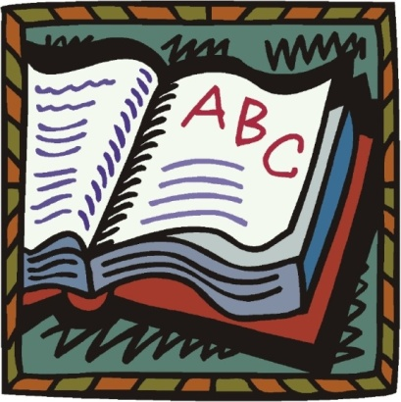
The reading age of the R.E. textbooks often far exceed that of the pupils which means that R.E. teachers need to check the readability level of any material they use in their teaching. The easiest way to establish the readability level of a text is to use an online SMOG calculator such as one that is available free at www.niace.org.uk/development-research/readability This can be used to calculate the readability level of any text that is pasted into it. The SMOG readability score for the text on this page is 18 years!
When it comes to literacy in R.E. classes pupils may have difficulty with their ability to:
- Comprehend instructional language – aural; written
- Demonstrate their learning through language – oral; written

R.E. teachers like all teachers must improve students’ ability to
- read/ comprehend language and
- produce language
and they must work creatively with vocabulary items and text elements.

Strategies for improving sight vocabulary /word recognition:
Keywords: Identify key words in a piece of text. List them. Pre-teach key words. Help the pupils understand it before they learn to spell it. Lists of key words should be contextualised for students. A keyword exercise that helps students to understand and remember key words is where learning takes place.
Key concepts: Check them out, list them, discuss and explain each one.
Word walls: Lists of keywords is displayed and each word is discussed. Pupils work in pairs. Each pair given one word and a blank post-it. The pair writes a definition of a keyword on the post-it and stick it on the keyword. Alternatively the pair give it to another pair who have to guess the keyword and place3 it correctly on the keyword word wall. Examples of keywords in the Junior Certificate R.E. syllabus are community, ritual, pilgrimage, penance, prayer, worship, transcendent, sacred etc.
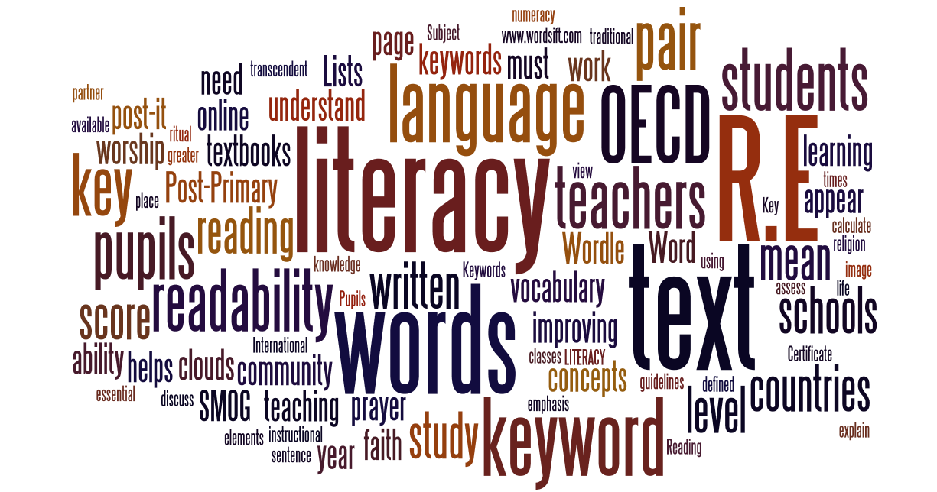
Word Cloud websites: Most classrooms are now equipped with computers and internet access and in some schools iPads have replaced traditional textbooks. Websites like www.wordle.net generate ‘word clouds’ from text that you provide. The clouds give greater prominence to words that appear more frequently in the source text. Example: This Wordle was made from the words on this page. The more times a word appears in the text, the bigger they appear in the Wordle image.

Another website is www.wordsift.com and this allows the user to click on words to view in an online visual thesaurus with dictionary, google images, and word sentence placement.
As is pointed out in the Bishop’s guidelines for junior and senior cycle Religious Education, the religious education of Catholic students in post-primary schools should always seek to support and inform their faith. Literacy strategies are essential in introducing young Catholics to the concepts and language of community, faith, worship, morality, prayer and service. Improving the literacy of pupils helps ensure that the study of religion in class can be both intellectually challenging and personally stimulating.

Gary Abrahamian
Post-Primary Diocesan Adviser
Dublin Archdiocese

