Human Rights
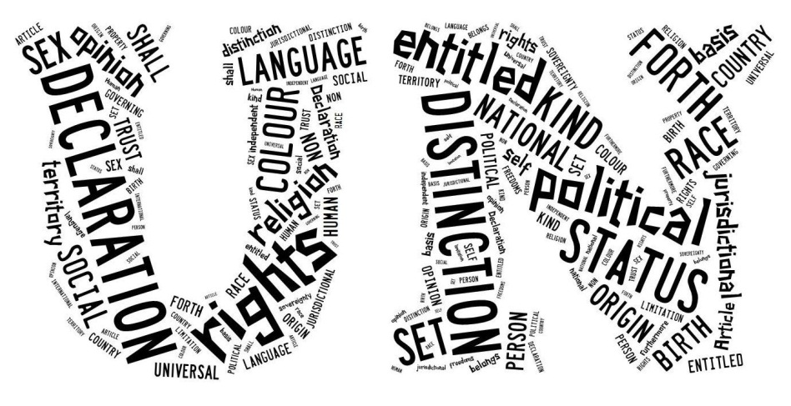
Everyone is entitled to all the rights and freedoms set forth in this Declaration, without distinction of any kind, such as race, colour, sex, language, religion, political or other opinion, national or social origin, property, birth or other status.
Furthermore, no distinction shall be made on the basis of the political, jurisdictional or international status of the country or territory to which a person belongs, whether it be independent, trust, non-self-governing or under any other limitation of sovereignty.
Universal Declaration of Human Rights Article 2

FOR YOU TO DO:

In your copy book consider:
- How you develop yourself – physically, socially, spiritually and intellectually.

- How the right to development of members of your own family, friends and classmates is promoted by you.

Now reflect on your efforts to promote the rights of people in:
Ireland
A developing country

Make a list of the values supported by the Universal Declaration of Human Rights.

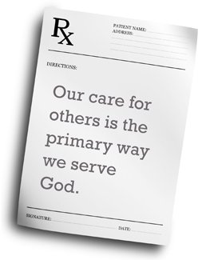
CHRISTIAN VIEWPOINT
‘Each individual is truly a person, with a nature that is endorsed with intelligence and free will, and rights and duties… these rights and duties are universal and inviolable.’
(Encyclical letter of Pope John XXIII)

‘No rights are possible without the basic guarantees for life, including the right … to adequate food, to guaranteed health care, to decent housing …’
(World Council of Churches)

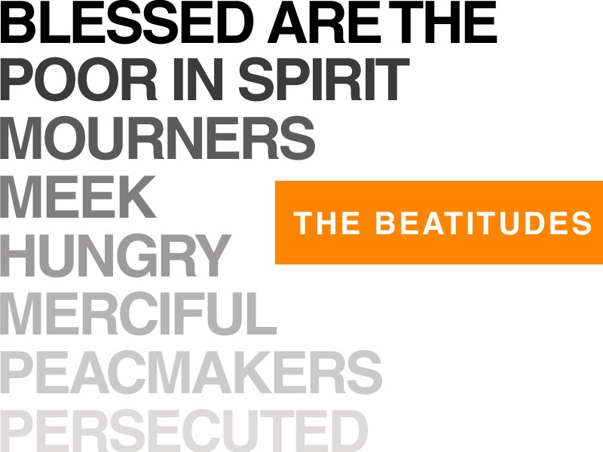
Blessed are the poor in spirit: for theirs is the kingdom of heaven.
Blessed are the meek: for they shall possess the land.
Blessed are they who mourn: for they shall be comforted.
Blessed are they that hunger and thirst after justice: for they shall have their fill.
Blessed are the merciful: for they shall obtain mercy.
Blessed are the clean of heart: for they shall see God.
Blessed are the peacemakers: for they shall be called the children of God. Blessed are they that suffer persecution for justice' sake, for theirs is the kingdom of heaven.
Matthew 5: 3-10

FOR YOU TO DO:

In your copy book consider:
- Which beatitude do you feel most comfortable with?
- Which one do you feel is part of who you are?
- Which one do you think you reflect most in your life? Briefly explain your answers.

Make a list of the values supported by the Beatitudes.
Compare this list with the list you made about the Universal Declaration of Human Rights.

Look up the following biblical references:
Lk. 6:35; Mt. 5:43-48; Lk. 6:27-35; Mt. 5:46,47; Gen. 1:27; John. 13:34; Lk. 10:27; James 2:20 and Lk. 10:29-37

Using one of these references, design a poster for your school prayer room or classroom.

