I believe

I believe- that our background and circumstances may have influenced who we are, but we are responsible for who we become.

I believe- that no matter how good a friend is, they're going to hurt you every once in a while and you must forgive them for that.

I believe- that just because someone doesn't love you the way you want them to doesn't mean they don't love you with all they have.

I believe- that true friendship continues to grow, even over the longest distance. Same goes for true love.

I believe- that it's taking me a long time to become the person I want to be.

I believe- that you should always leave loved ones with loving words. It may be the last time you see them.

I believe- that you can keep going, long after you can't.

I believe- that we are responsible for what we do, no matter how we feel.

I believe- that either you control your attitude or it controls you.

I believe- that heroes are the people who do what has to be done when it needs to be done, regardless of the consequences.

I believe- that money is a lousy way of keeping score.

I believe- that my best friend and I can do anything or nothing and have the best time.

I believe- that sometimes the people you expect to kick you when you're down, will be the ones to help you get back up.
I believe- that sometimes when I'm angry I have the right to be angry, but that doesn't give me the right to be cruel.

I believe- that maturity has more to do with what types of experiences you've had and what you've learned from them and less to do with how many birthdays you've celebrated.

I believe- that it isn't always enough to be forgiven by others. Sometimes you have to learn to forgive your self.

I believe- that no matter how bad your heart is broken the world doesn't stop for your grief.

I believe- that just because two people argue, it doesn't mean they don't love each other. And just because they don't argue, it doesn't mean they do.

I believe- that you shouldn't be so eager to find out a secret. It could change your life forever.

I believe- that two people can look at the exact same thing and see something totally different.

I believe- that your life can be changed in a matter of hours by people who don't even know you.

I believe- that even when you think you have no more to give, when a friend cries out to you you will find the strength to help.

I believe- that credentials on the wall do not make you a decent human being.
I believe- that the people you care about most in life are taken from you too soon. ~Author unknown

A Creed To Live By Nancye Sims
Don't undermine your worth by comparing yourself with others.
It is because we are different that each of us are special. Don't set your goals by what other people deem important. Only do what is best for you.
Don't take for granted the things closest to your heart. Cling to them as you would your life, for without them life is meaningless.
Don't let life slip through your fingers by living in the past or in the future. By living one day at a time you live all days of your life.
Don't give up when you still have something to give. Nothing is really over until the moment you stop trying.
Don't be afraid to admit that you are less than perfect. It is the fragile thread that binds us to each other.
Don't be afraid to encounter risks. It is by taking chances that we learn how to be brave.
Don't shut love out of your life by saying it is impossible. The fastest way to lose love is to hold to it tightly, and the best way to keep love is to give it wings.
Don't dismiss your dreams. To be without dreams is to be without hope, to be without hope is to be without purpose.
Don't run through life so fast that you forget not only where you have been, but also where you are going. Life is not a race, but a journey to be savoured each step of the way.
This is what we are about
This is what we are about.
We plant the seeds that one day will grow.
We water seeds already planted,
knowing that they hold future promise.
We lay foundations that will need further development.
We provide yeast that produces far beyond our capabilities.
We cannot do everything, and there is a sense of liberation
in realizing that. This enables us to do something,
and to do it very well. It may be incomplete,
but it is a beginning, a step along the way,
an opportunity for the Lord's grace to enter and do the rest.
We may never see the end results, but that is the difference
between the master builder and the worker.
We are workers, not master builders; ministers, not messiahs.
We are prophets of a future not our own.
Amen.
Oscar Romero

The Invitation - Oriah Mountain Dreamer
It doesn't interest me what you do for a living. I want to know what you ache for and if you dare to dream of meeting your heart's longing.
It doesn't interest me how old you are. I want to know if you will risk looking like a fool for love, for your dream, for the adventure of being alive.
It doesn't interest me what planets are squaring your moon. I want to know if you have touched the centre of your own sorrow, if you have been opened by life's betrayals or have become shrivelled and closed from fear of further pain.
I want to know if you can sit with pain, mine or your own, without moving to hide it, or fade it, or fix it.
I want to know if you can be with joy, mine or your own; if you can dance with wildness and let the ecstasy fill you to the tips of your fingers and toes without cautioning us to be careful, be realistic, remember the limitations of being human.
It doesn't interest me if the story you are telling me is true. I want to know if you can disappoint another to be true to yourself.
If you can bear the accusation of betrayal and not betray your own soul. If you can be faithless and therefore trustworthy.
I want to know if you can see Beauty even when it is not pretty every day. And if you can source your own life from its presence.
I want to know if you can live with failure, yours and mine, and still stand at the edge of the lake and shout to the silver of the full moon, 'Yes.'
It doesn't interest me to know where you live or how much money you have. I want to know if you can get up after the night of grief and despair, weary and bruised to the bone and do what needs to be done to feed the children.
It doesn't interest me who you know or how you came to be here. I want to know if you will stand in the centre of the fire with me and not shrink back.
It doesn't interest me where or what or with whom you have studied. I want to know what sustains you from the inside when all else falls away.
I want to know if you can be alone with yourself and if you truly like the company you keep in the empty moments.
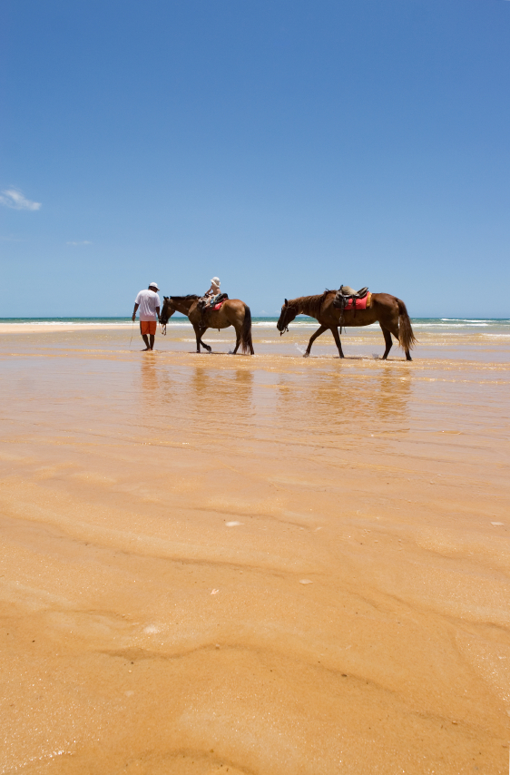
Trust in God

Often your tasks will be many,
And more than you think you can do…
Often the road will be rugged
And the hills insurmountable, too…
But always remember, the hills ahead
Are never as steep as them seem,
And with Faith in your heart start upward
And climb ‘til you reach your dream,
For nothing in life that is worthy
Is ever too hard to achieve
If you have the courage to try it
And you have the Faith to believe…
For Faith is a force that is greater
Than knowledge or power or skill
And many defeats turn to triumph
If you trust in God’s wisdom and will…
For Faith is a mover of mountains,
There’s nothing that God cannot do,
So start out today with Faith in your heart
And “climb ‘til your dream comes true”!
Journey Ends …….Journey begins
For each of us life is a journey Birth is the beginning of this journey
And death is not the end but the destination it is a journey that takes us from youth to age
From innocence to awareness from foolishness to wisdom
From weakness to strength and often back again
From loneliness to friendship from pain to compassion
From fear to faith from defeat to victory and
From victory to defeat until looking backward or ahead
We see that victory does not lie at some high point along the way
But in having made the journey Stage by stage.
A Graduate’s Prayer
As I look toward the future
Bright hope conducts this prayer,
For I know the plans You have for me
Were wrought with divine care.
Holy Spirit, lead me.
Let me run at your command,
Yet be still and know that You are God
When trouble's close at hand.
Your Word will be a lamp for me,
A guide to light my way,
A solid place to set my feet,
A compass when I stray.
May I live my life to praise You,
Not for fortune, nor for fame,
May everything I say and do
Bring glory to your name.
May my eyes stay fixed upon You
As I seek the way that's pure,
Tasting your love and goodness
Sleeping and rising secure.
Planted by your living streams
I'll delight in all your ways,
Hidden by your sheltering wings
With new mercies for each day.
Even in a dangerous land
When storms threaten to destroy,
At the cross I'll stand upon the Rock
My Strength, my Hope, my Joy.
Dear Lord, show me your favor,
At all times keep me blessed,
May your face ever shine upon me,
With peace and perfect rest.
Amen.

"To Risk"

To laugh is to risk appearing a fool,
To weep is to risk appearing sentimental
To reach out to another is to risk involvement,
To expose feelings is to risk exposing your true self
To place your ideas and dreams before a crowd is to risk their loss
To love is to risk not being loved in return,
To hope is to risk despair,
To try is to risk to failure.
But risks must be taken because the greatest hazard in life is to risk nothing.
The person who risks nothing, does nothing, has nothing is nothing.
He may avoid suffering and sorrow,
But he cannot learn, feel, change, grow or live.
Chained by his servitude he is a slave who has forfeited all freedom.
Only a person who risks is free.
The pessimist complains about the wind;
The optimist expects it to change;
And the realist adjusts the sails.
-William Arthur Ward,



