Prayer Service for Feast of St Patrick
Bishop, Principal Patron of Ireland

Set up a prayer space:
1. Picture or statue of St Patrick or a mountain scene with sheep grazing. Students may do
centre piece in art class.
2. Green material on which symbols may be placed - rocks/stones/plants/flowers/shamrock/
candles.

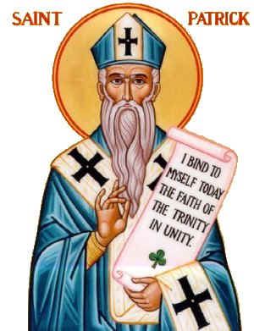
Gathering song: Ag Críost an Síol
Introduction
Saint Patrick was born early in the 5th century in Britain. At the age of sixteen he was taken captive and brought to Ireland where he worked as a slave. Life was not easy for Patrick as a young man as he worked long hours on the bleak hillside minding sheep. After six years he escaped back to Britain to his family who were glad to see him return home.
Patrick became a Christian and he visited France where he continued his studies after scriptures and reflected on Christ's teaching. Near at the end of his life he put in writing his reflections on his search for God and the blessings God had given him in his life. In the Confessions of St Patrick, we read of the absolute trust Patrick had in God’s loving care for him, his gratitude for the gift of faith and he rejoiced in the way God had transformed the lives of Irish men and women who became Christian on his return to the island as a missionary. Today we celebrate the great blessings entrusted on Patrick by God to bring the good news: Christ the Light of our World to our land.

As we gather to celebrate the feast of St Patrick let us remember the many Irish people who are far from home. Let us give thanks for the gifts that each of us have received and we ask the Spirit to help us to be generous in using our talents for the good of the community.

Prayer:
We realise, O Jesus, your presence among us, for we are gathered together in your name. Awaken us to your glory that we may see you in your creation the goodness of those who live with us and touch our lives. May we be true to God the Father who created the world, to the son of God who redeemed us and to God the Holy Spirit who sustains and guides us. Amen

Litany of Praise

We give thanks for St Patrick who worked hard as a slave minding sheep on the hillside.
Response: Praise the name of the Lord

We give thanks for St Patrick who returned home to be with his family and for the courage he had to study the Christian way of life.
Response: Praise the name of the Lord

We give thanks for St Patrick who journeyed to France to increase his knowledge of the Scriptures and to discover what the gift of faith had to offer.
Response: Praise the name of the Lord

We give thanks for St Patrick who reflected on his experience of God in the beauty of nature and in the lives of people who shared in his life’s journey.
Response: Praise the name of the Lord

We give thanks for St Patrick’s call to convert the people of Ireland to follow Christ in his way of love.
Response: Praise the name of the Lord
Reading (Extracts from St Patrick’s Confession)

"So I am first of all a simple country person, a refugee, and unlearned. I do not know how to provide for the future. But this I know for certain, that before I was brought low, I was like a stone lying deep in the mud. Then He who is powerful came and in his mercy pulled me out, and lifted me up and placed me on the very top of the wall. That is why I must shout aloud in return to the Lord for such great good deeds of his, here and now and forever, which the human mind cannot measure.

If I am most looked down upon, yet he inspired me, before others, so that I would faithfully serve the nations with awe and reverence and without blame: the nations to whom the love of Christ brought me. His gift was that I would spend my life, if I were worthy of it, to serving them in truth and with humility to the end.

In the knowledge of this faith in the Trinity, and without letting the dangers prevent it, it is right to make known the gift of God and his eternal consolation. It is right to spread abroad the name of God faithfully and without fear, so that after my death I may leave something of value to the many thousands of my brothers and sisters – the children whom I baptised in the Lord.”

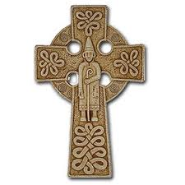
Quiet moment for reflection. Music playing softly in the background.

Psalm 117

Praise the Lord all you Nations!
Praise him, all Peoples!
His love is strong and his faithfulness is eternal.
Praise the Lord all you Nations.

Gospel Reading: Mark 16: 15-18

Prayers of Intercession

Response - Lord Hear our Prayer

Christ within us, help us to spread the word of love, peace and justice in our world.
Lord Hear our Prayer

Christ in all hearts, be with your people as they share the good news of the gospel in places where your word is not known.
Lord Hear our Prayer

Christ beside us, help us to trust in you when we meet difficulties and sustain us in our journey of faith.
Lord Hear our Prayer

Christ, who guided Patrick through the struggles of slavery and poverty be with the Irish people as they face hardship in their everyday life.
Lord Hear our Prayer

Christ be the light of all our immigrants as they face challenges far away from home. Help them through loneliness and the fear of the unknown.
Lord Hear our Prayer

Christ be with all our Missionaries who are working to bring the gospel to our brothers and sisters in different lands. Be with each of us gathered in your name and help us to be true to the faith that St Patrick preached to our ancestors.
Lord Hear our Prayer

Prayer of blessing over the bowl of shamrock. (All extend their hands as a gesture of unity)

Lord, bless these sprigs of shamrock which St Patrick used as a symbol to help our ancestors understand the mystery of the Blessed Trinity, Father, Son and Holy Spirit. Let us ask God to bless each of us and help us to remain faithful to our baptismal calling by living lives of faith, hope and love. Amen

Let us offer each other a sign of peace.

Reflection:

I bind unto myself today
The strong name of the Trinity
By invocation of the same,
The three in one and One in three.

I bind unto myself today
The power of God to hold and lead.
His eye to watch. His might to stay,
His need to harken to my need.
The wisdom of my God to teach.
His hand to guide, his shield to ward;
The word of God to give me speech,
His heavenly host to be my guard.
(taken from the Breastplate of St Patrick)

Concluding Prayer

O God, we celebrate your gifts of holiness, leadership and service in the life of St Patrick. Bless our country, renew the faith of our people and breathe new life into each of us as we give thanks for our love and care of our nation, in the name of Jesus our Lord who lives and reigns with the Father and the Holy Spirit, world without end. Amen.

Blessing:

May the Lord bless you and keep you. Amen
May his face shine on you and be gracious to you. Amen
May he look upon you with kindness and give you his peace. Amen

Recessional Hymn

Hail Glorious St Patrick
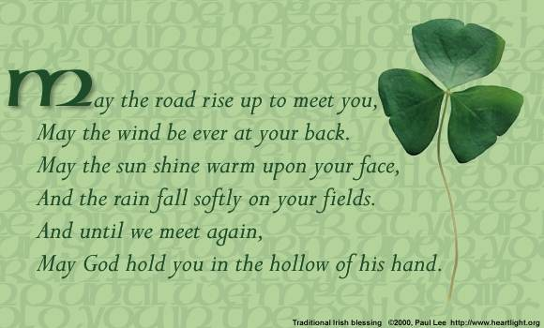
(CD Faith of our Fathers the 10th Anniversary RTE/classical religious anthems of Ireland)

